DDAS Test Procedures

# Login

|  |  |  |  |  |
| --- | --- | --- | --- | --- |
| **Sr. No** | **Check Item** | **Test Case Objective** | **Steps to Execute** | **Expected Results** |
| 1 | User Login | Check When pass invalid user name | 1. Enter invalid username(**user10**)  2. Enter correct password(**Pass!234**)  3. Click on Login Button | User should not be able to login and should show error message |
| 2 | User Login | Check When pass correct username and invalid password | 1. Enter valid username(**user1**)  2. Enter incorrect password(**Pass!2345**)  3. Click on Login Button | User should not be able to login and should show error message |
| 3 | User Login | Check when pass correct username and password | 1. Enter valid username(**user1**)  2. Enter incorrect password(**Pass!234**)  3. Click on Login Button | User should be able to login |

# Download Batch Upload Template

|  |  |  |  |  |  |
| --- | --- | --- | --- | --- | --- |
| **Sr. No** | **Test Cases** | **Check Item** | **Test Case Objective** | **Steps to Execute** | **Expected Results** |
| 1 | TC-001 | Batch Upload Template | Check whether the template can be downloaded | Click on ‘Batch Upload Template’ button  (Refer to the below image) | An excel file with the name **DDAS_Upload_Template.xlsx**  Will be downloaded |

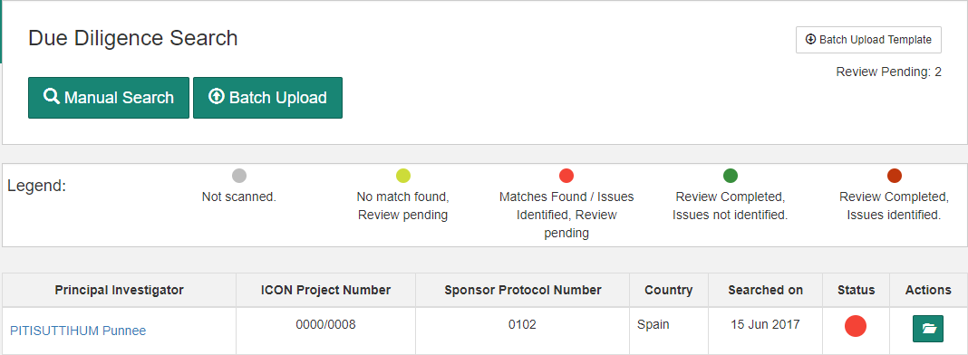

# Batch Upload

|  |  |  |  |  |
| --- | --- | --- | --- | --- |
| **Sr. No** | **Check Item** | **Test Case Objective** | **Steps to Execute** | **Expected Results** |
| 1 | Batch Upload | Check whether the file downloaded in the previous step can be uploaded into the application | Click on ‘Batch Upload’ button  In the home screen | Check below image  ‘**On upload**  **Successful**’. When the file is uploaded with required information, the investigator names appear as per the uploaded file |
| 2 | Batch Upload | Check whether a batch upload template with incorrect project number is uploaded | Click on ‘Batch Upload’ button in the home screen | Check below image ‘**On upload unsuccessful**’ |

**On upload successful**

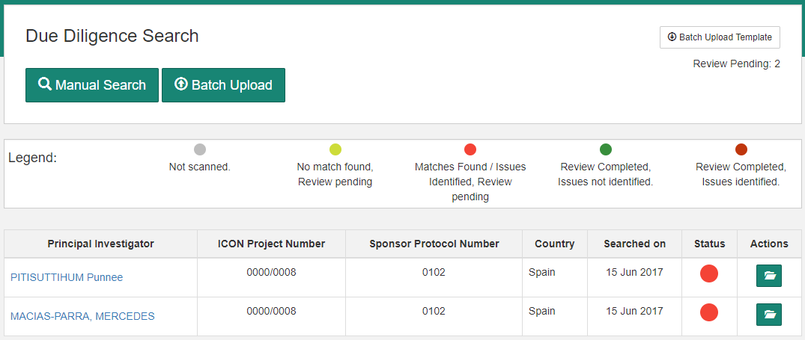

**On upload unsuccessful**

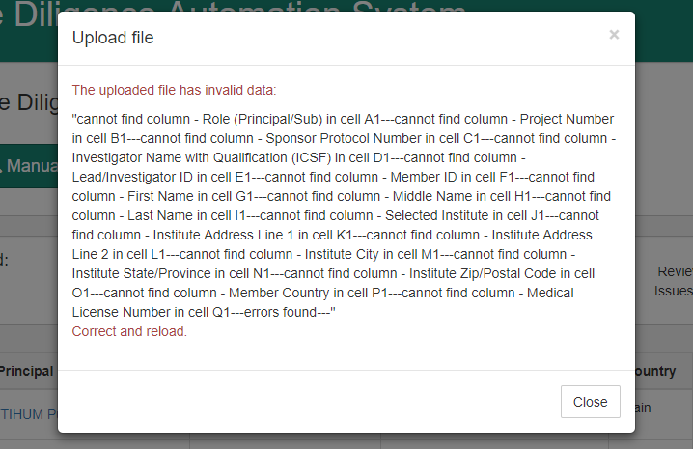

# Reset Password

|  |  |  |  |  |
| --- | --- | --- | --- | --- |
| **Sr. No** | **Check Item** | **Test Case Objective** | **Steps to Execute** | **Expected Results** |
| 1 | Reset Password | Check whether an email is sent to reset user password | Navigate to ‘Users’ tab. Click on ‘Reset Password’ button for any user | Message ‘Password Reset. Mail sent to the user - admin’  Should be displayed  at the bottom |

# App Admin

Login with the user name - **AppAdmin1** and password - **Pass!234**

|  |  |  |  |  |
| --- | --- | --- | --- | --- |
| **Sr. No** | **Check Item** | **Test Case Objective** | **Steps to Execute** | **Expected Results** |
| 1 | Data Extraction History | Check whether ‘Data Extraction History’ tab is displaying all DB sites along with extraction details | Login as App Admin with the credentials provided above and Navigate to ‘Data Extraction History’ tab under the ‘App Admin’ section | Data extraction details should be displayed for FDA Debar Page by default |

# Site Sources

|  |  |  |  |  |
| --- | --- | --- | --- | --- |
| **Sr. No** | **Check Item** | **Test Case Objective** | **Steps to Execute** | **Expected Results** |
| 1 | Site sources | Check whether all site sources are available under ‘Site Sources’ tab | Login with the Admin credentials and Navigate to ‘Site Sources’ tab under the ‘Configurations’ section | Site source details should be displayed |
| 2 | Site Sources | Create a site source | Login as Admin,  Navigate to ‘Site Sources’ tab under the ‘Configurations’ section.  Provide site name and URL to create a site source | New site source should be displayed along with other site sources |

# Default Sites

|  |  |  |  |  |
| --- | --- | --- | --- | --- |
| **Sr. No** | **Check Item** | **Test Case Objective** | **Steps to Execute** | **Expected Results** |
| 1 | Default Site Source | Add default site sources under ‘Default Site Sources’ tab. Sites added under this section will be searched by default. | Login with the Admin credentials and Navigate to ‘Default Sites’ tab under the ‘Configurations’ section | Default site sources should be displayed |

# Country Specific Site Sources

|  |  |  |  |  |
| --- | --- | --- | --- | --- |
| **Sr. No** | **Check Item** | **Test Case Objective** | **Steps to Execute** | **Expected Results** |
| 1 | Country specific site sources | Add site source specific to a country | Login with the Admin credentials and Navigate to ‘Country Specific Site Sources’ tab under the ‘Configurations’ section.  Select a site source, enter country name, select search applies to and save | Country specific site should be displayed |

# Sponsor Specific Site Sources

|  |  |  |  |  |
| --- | --- | --- | --- | --- |
| **Sr. No** | **Check Item** | **Test Case Objective** | **Steps to Execute** | **Expected Results** |
| 1 | Sponsor specific site sources | Add site source specific to a sponsor protocol number | Login with the Admin credentials and Navigate to ‘Sponsor Specific Site Sources’ tab under the ‘Configurations’ section.  Select a site source, enter sponsor protocol number, select search applies to and save | Sponsor specific site should be displayed |

# Compliance Search Form

|  |  |  |  |  |
| --- | --- | --- | --- | --- |
| **Sr. No** | **Check Item** | **Test Case Objective** | **Steps to Execute** | **Expected Results** |
| 1 | Upload compliance form template | Upload and check the result of a compliance form template with the investigator name ‘Spencer Wayne’ | Download batch upload template as described earlier. Enter investigator Name as ‘Spencer Wayne’ and upload the template into the application | Application should display Full Match for 6 site sources |
| 2 | Completing Review | Complete Review for all site sources for the investigator ‘Spencer Wayne’ | Navigate to each site source findings and mark as ‘review completed’ | Upon completing the review for all site sources, the compliance form should be moved under the tab ‘Closed Reviews’ |
| 3 | Downloading ICSF | To download ICSF and check whether required information is available | Navigate to ‘Closed Reviews’ tab and download the ICSF in word document format | ICSF in word document format should be downloaded |

# All Searches

|  |  |  |  |  |
| --- | --- | --- | --- | --- |
| **Sr. No** | **Check Item** | **Test Case Objective** | **Steps to Execute** | **Expected Results** |
| 1 | All Searches (all compliance forms) | Check whether all searches carried out in the application are available | Navigate to ‘All Searches’ tab. Use the filters to get required searches. Application displays searches carried out by any user. These searches can be downloaded | All searches carried out should be displayed |

# Output Report

|  |  |  |  |  |
| --- | --- | --- | --- | --- |
| **Sr. No** | **Check Item** | **Test Case Objective** | **Steps to Execute** | **Expected Results** |
| 1 | Output report | Download output report | Navigate to ‘Output Report’ tab. Provide the date filters to get the output file within the date range | An excel file should be downloaded with each investigator details within the given date range |

# Manage Reassignments

|  |  |  |  |  |
| --- | --- | --- | --- | --- |
| **Sr. No** | **Check Item** | **Test Case Objective** | **Steps to Execute** | **Expected Results** |
| 1 | Reassign compliance forms | Reassign compliance forms to users | Login as admin, Navigate to ‘Manage Reassignments’ tab. Assign a compliance form to any user | Compliance form should be updated under the newly assigned user |